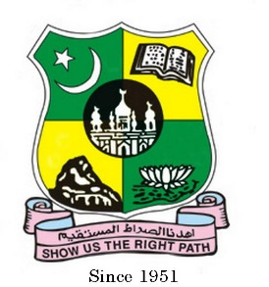
ZoolJAMAL MOHAMED COLLEGE (Autonomous)
Accredited (3rd Cycle) with ‘A’ Grade by NAAC
(Affiliated to Bharathidasan University)
TIRUCHIRAPPALLI – 620 020

REPORT

The Zoology (SF - Women) Association 2023 – 2024 special lecture was held on 31.08.2023, Thursday at 3:30 p.m in Commerce Gallery.
The Program started as the Chief Guest and other Dignitaries arrived at the college premises at 3.30 p.m. The Master of ceremony was Ms.R.T.Yazmin sidhika of III BSc Zoology, Ms.Jumana of II BSc Zoology and Ms.A. Jahanara Begum of I BSc Zoology.The occasion began with the faith of prayer by Ms R.T Yazmin Sidhika of III BSc Zoology from the Holy Quran.
The students Kindled their love for the mother land by singing the Tamil Thai Valthu.To give a warm and pleasant welcome Dr. I Joseph Antony Jerald Head of the department welcomed the gathering with his sweet words of welcome.
Additional Vice Principal MS. A Famitha Banu was there to Felicitate the gathering with the great encouragement towards the students.
Dr. P. Dhanalakshmi Vice- President of Zoology Association welcomed the Chief Guest with the pleasure.
The honorable chief guest was Dr. V. Anandhi., Associate professor, & HOD Department of Anatomy K. A. P. V , Medical College,Trichy.
The chief Guest gave an inspiring and intellectual special lecture on “ The Development of Human” which made the Students of Zoology department,Bio-tech department and Micro Biology was informative and enlightened by the Chief Guest’s speech.
Mrs. H.F. Syed Mafiya Haniff , MID Zoology (SF-W) gave her gratitude towards the management and the chief guest to give the students an inspiring lecture. With the patriotism for the mother land the students sang the National Anthem. Our Guest graced us with their valuable words. The program marked it conclusion by 6:00 p.m

